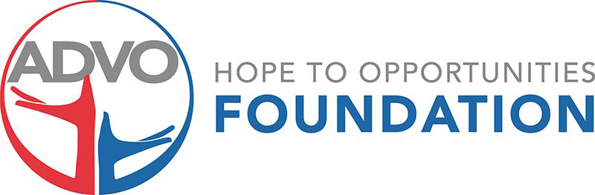

BBQ for Hope
State Qualifying IBCA BBQ Event
October 13-14, 2023, benefiting Advo/Hope to Opportunities Foundation
5241 S Washington, Amarillo TX 79110

Title Sponsor - $2,500, includes 2 cook teams, all media post, flyers, banners, and opportunity to speak at the awards ceremony

Awards Sponsor - $1,000, includes cook team and logo on banner and
all media for the event, plus logo on award plague

Banner Sponsor - $500, includes cook team and logo on banner and all media for the event

Team Fee $150 for one or all three meat categories

Cook will include Brisket, Spare Ribs, and Chicken
Awards and Cash payments for 1st, 2nd, 3rd in each category and
Grand Champion and Reserve Champion

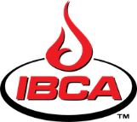Sanctioned Rules and Event 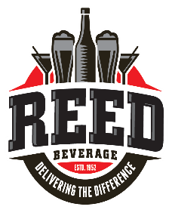Beverage Sponsor

Contact Jeremy Bradford
For information, forms, and registration
jbradford@htofoundation.org
806-342-0600 https://www.htofoundation.org/events

